SQL Outputs

1. When considering total number of items purchased from receipts with 'rewardsReceiptStatus’ of ‘Accepted’ or ‘Rejected’, which is greater?

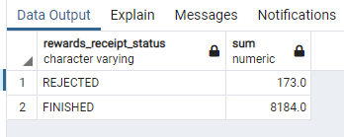

1. When considering average spend from receipts with 'rewardsReceiptStatus’ of ‘Accepted’ or ‘Rejected’, which is greater?

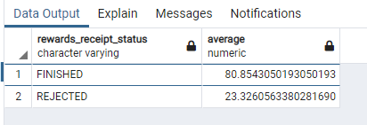

1. What are the top 5 brands by receipts scanned for most recent month?

The results below are for January, which has the most number of records.

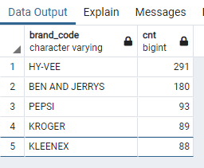

There are 6 records for February, the most records are in January and no records in March, April   
or May

1. Which brand has the most spend among users who were created within the past 6 months?

The first result is null because a lot of items don't have the brand captured, but excluding that Ben and Jerry's seem to be the most spent brand.

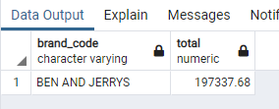

Data Quality –

